**CONDUCT DATA-TO BE FILLED IN BY YOUR SCHOOL PRINCIPAL OR STD. VI TEACHER**

| **II. Check the column to correspond with your rating of the student using the following scale:**  **1. Exceptional 2. Very Good 3. Average 4. Below Average 5. Poor** | | | | | |
| --- | --- | --- | --- | --- | --- |
| **CATEGORY** | **1** | **2** | **3** | **4** | **5** |
| Learning Potential |  |  |  |  |  |
| Reading Ability |  |  |  |  |  |
| Willingness to abide by school rules |  |  |  |  |  |
| Willingness to accept correction or discipline |  |  |  |  |  |
| Dedication to school work |  |  |  |  |  |
| Attitude towards authority |  |  |  |  |  |
| Ability to get along with others |  |  |  |  |  |

**OVERALL RECOMMENDATION – TO BE FILLED IN BY YOUR SCHOOL PRINCIPAL OR STD. VI TEACHER**

**III. Please circle the number of the phrase which most accurately completes the following statement:**

1. I enthusiastically recommend 2. I strongly recommend

3. I recommend 4. I recommend without enthusiasm

5. I do not recommend

this applicant for admission into Wesley College.

________________________________________ _______________________________

Signature of Recommender Date

***********************************************************

**FOR OFFICIAL USE ONLY**

**OVERALLSCORE: __________ Comments:**



**WESLEY COLLEGE – BELIZE CITY**

**2022 - APPLICATION FOR ADMISSION**

**(Answer ALL questions – Only fully completed APPLICATION forms will be accepted)**

**INSTRUCTIONS**

1. Carefully complete the application in bold printed letters. All Questions must be answered.
2. Ask your School Principal or STD VI teacher to complete the recommendation form.
3. Attach a non-refundable application fee of **$20.00** to the form
4. A fee of **$25.00** will be charged for late applications.
5. Return the completed form **with a certified copy of Birth Certificate, Social Security Card on, or before April 08, 2022** to: Principal, Wesley College, 34 Yarborough Road, Belize City, Belize
6. Await a written response through your school indicating acceptance/non-acceptance. **Applicants from schools outside of Belize City must provide a contact number for a parent/guardian.**
7. An interview may be required as part of the application process.

The provision of a Secondary Education in Belize is based on a partnership shared by the school, parents/guardians, and the Government of Belize. As an integral part of this partnership, parents/ guardians are asked to commit to these activities: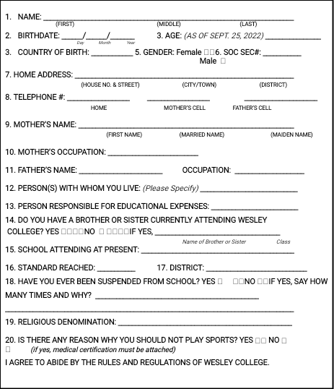

**PARENT/GUARDIAN’S COMMITMENT**

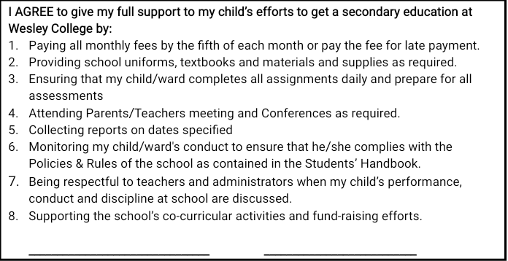

The Principal or Std. VI Homeroom Teacher is asked to provide complete and accurate data and to give

an honest assessment of the applicant’s readiness for High School.

**PERFORMANCE DATA – TO BE FILLED IN BY YOUR SCHOOL PRINCIPAL OR**

**STD VI TEACHER**

